

Project Name: CONNECT TO YOUR DOCTOR

Branch PG-DAC Sep- 2021.

Documentation On

**“CONNECT TO YOUR DOCTOR”**

PG-DAC Sep 2021

**Guided By: Mrs. Bakul Joshi**

Submitted By :

**Group No: 04**

* **Lathkar Mayuresh 210943020043**
* **Zanzane Mrunal 210943020052**
* **Narwade Niraj 210943020056**
* **Dandge Vikas 210943020109**

**Table of Contents**

**1. Introduction 4**

1.1 Document Purpose **4**

1.2 Project Background **4**

1.3 Aim & Objectives **4**

**2. Business Requirements Overview**…………………………………………………………**5**

**3.Functional Requirements** **5**

3.1 Admin Module **5**

3.2 Doctor Module **6**

3.3 Patient Module **6**

**4.** **Non-Functional Requirement………………………………………………………………6**

**5. Use Case Diagram 7**

5.1 Admin **7**

5.2 Doctor **8**

5.3 Patient **9**

**6. Database Design 10**

1 Login **10**

2 Doctor **10**

3 Patient **10**

4 State **11**

5 City **11**

6 Area **11**

7 Doctor Time Table **11**

8 Appointment **12**

**7. E-R Diagram………………………………………………………………………………………13**

**8. Snapshots 14**

**9. Conclusion 30**

**List of Figures**

**Use Case Diagrams 7**

Fig 1 Admin 7

Fig 2 Doctor 8

Fig 3 Patient 9

Fig 4 ER Diagram 12

1. **Introduction:**
   1. **Document Purpose:**

This document explains the system requirements and scope for developing Connect To Your Doctor portal. Connect To Your Doctor portal could divide the three main parts, Admin part, Patient part and Doctor part.

## Project Background:

During pandemic Covid-19 was on high priority and almost all doctors were on duty at Covid-19care centers which lead to negligence towards other diseases. Many patients suffered amidst pandemic due to unavailability of doctor’s appointment. Lockdown restrictions made it more difficult to get information about available appointment slot and doctor’s availability. Conventional medical treatment and health checkup is proven to be not feasible in these pandemic like situations. There has to be some virtual medium which will provide ease to both patients and doctors.

## Aim & Objectives:

* The purpose of our Project “Connect To Your Doctor” is to automate the process of getting medical treatment and health checkup in a way that saves both time and effort.
* This application manages all the information of patients and doctors.
* The project is developed at administrative end and thus only the administrator is guaranteed to have access to everything.
* This web application reduces the manual efforts of looking for a doctor and booking appointments.

1. **Business Requirements Overview:**

* Connect To Your Doctor is the public web application.
* Connect To Your Doctor will be opened to the global, but in the phase 1, the main target is in the Maharashtra.
* There are mainly two types of users. One is the Doctor and other is Patient.
* Patients can search for the available specialist Doctors in respective location.
* Doctor can create appointment slots based on available time and can check information about the booked appointments.
* Connect To Your Doctor provides the facility to connect the patients with the doctor efficiently.
* Connect To Your Doctor could be maintained by Administrator.

# Functional Requirements Overview:

Connect To Your Doctor consists of three modules described as below.

1. Admin Module
2. Doctor Module
3. Patient Module

# **Admin Module**

* Connect To Your Doctor provide all functionality to admin how to handle the System.
* Admin can register the new doctor when credentials found authentic.
* Admin has controls and can see the Patient details and Doctor details.
* Admin can see the Patient details and also if admin found any details in-appropriate, admin can delete those entries.
* Admin can see the Doctor details and also if admin found any details in-appropriate, admin can delete those entries.
* Admin can deactivate the Patient or Doctor temporarily or permanently.
* Admin can add Area, City, State according to the need.

# **Doctor Module**

* Doctor can update his profile as per his/her requirements.
* Doctor can see the current appointments and appointment history.
* Doctor can cancel appointment incase of emergency.
* Doctor can update timetable according to availability and holidays.
* Doctor can change existing password.

# **3.3 Patient Module**

* Patient can update his profile as per his/her requirements.
* Patient can search doctors according to locality and specialty of doctor.
* Patient can see the current appointments and appointment history.
* Patient can cancel appointment in case of emergency.
* Patient can change existing password.

1. **Non-Functional Requirement:**

* The website should use professional design, look and feel and color scheme.
* Users will have no limitations for accessing the application through Internet. The portal being an internet application, it is difficult to specify exact number of visitor or users. Hence, we will target the system to support between 5 and 10 million users on launch of phase 1.
* Being a public website, the site must follow general usability guidelines for menus, navigation, colors, links and other actions provided on the screens.
* The system should be designed in such a manner that user will be able to complete tasks in minimum number of steps.

## 5. Use-Case Diagram

**5.1 Admin**

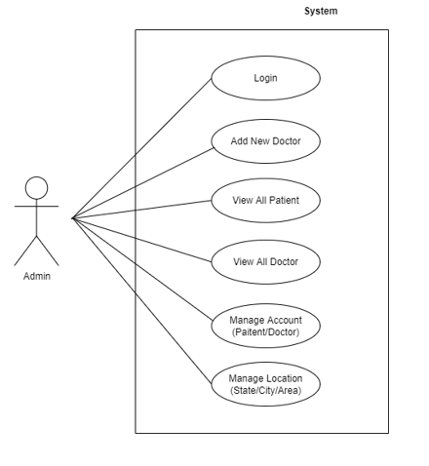

`Fig. Use-Case Diagram for Admin

## 5.2 Doctor

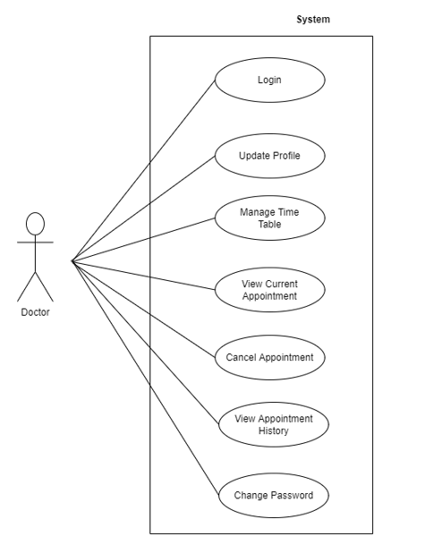

Fig. Use-Case Diagram for Doctor

**5.3 Patient**

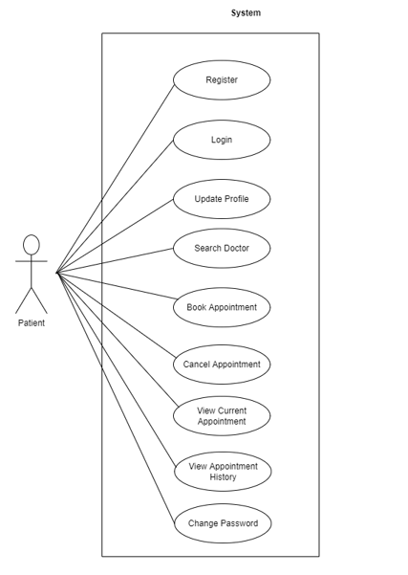

Fig. Use-Case Diagram for Patient

**6. Database Design:**

**1] Login table**

|  |  |  |  |  |  |
| --- | --- | --- | --- | --- | --- |
| **Field** | **Type** | **Null** | **Key** | **Default** | **Description** |
| login_id | Integer | No | Primary key | AI | Login ID |
| user_name | Varchar(45) | No |  |  | User Name |
| password | Varchar(45) | No |  |  | User Password |
| user_type | Varchar(10) | No |  |  | Patient/ Doctor/ Admin |
| status | Varchar(10) |  |  | active |  |

**2] Doctor table**

|  |  |  |  |  |  |
| --- | --- | --- | --- | --- | --- |
| **Field** | **Type** | **Null** | **Key** | **Default** | **Description** |
| doctor_id | Integer | No | Primary key | AI | Doctor ID |
| first_name | Varchar(45) | No |  |  | First Name |
| last_name | Varchar(45) | No |  |  | Last Name |
| mobile_number | Varchar(45) | No | Unique key |  | Mobile Number |
| gender | Integer | No |  |  | Gender |
| dob | date | No |  |  | Date Of Birth |
| graduation | Varchar(45) | No |  |  | Graduation |
| post_ graduation | Varchar(45) |  |  |  | Post Graduation |
| speciality | Varchar(45) | No |  |  | Speciality |
| fees | Integer | No |  |  | Fees |
| area_id | Integer | No | Foreign key |  | Reference to area id |
| login_id | Integer | No | Foreign key |  | Reference to login id |

**3] Patient table**

|  |  |  |  |  |  |
| --- | --- | --- | --- | --- | --- |
| **Field** | **Type** | **Null** | **Key** | **Default** | **Description** |
| patient_id | Integer | No | Primary key | AI | Patient ID |
| first_name | Varchar(45) | No |  |  | First Name |
| last_name | Varchar(45) | No |  |  | Last Name |
| mobile_number | Varchar(45) | No | Unique key |  | Mobile Number |
| gender | Varchar(45) | No |  |  | Gender |
| blood_group | Varchar(45) | No |  |  | Blood Group |
| dob | date | No |  |  | Date Of Birth |
| login_id | Integer | No | Foreign key |  | Reference to login id |

**4] State table**

|  |  |  |  |  |  |
| --- | --- | --- | --- | --- | --- |
| **Field** | **Type** | **Null** | **Key** | **Default** | **Description** |
| state_id | Integer | No | Primary key | AI | State ID |
| state_name | Varchar(45) | No |  |  | State Name |

**5] City table**

|  |  |  |  |  |  |
| --- | --- | --- | --- | --- | --- |
| **Field** | **Type** | **Null** | **Key** | **Default** | **Description** |
| city_id | Integer | No | Primary key | AI | City ID |
| city_name | Varchar(45) | No |  |  | City Name |
| State_id | Integer | No | Foreign Key |  | Reference to state id |

**6] Area table**

|  |  |  |  |  |  |
| --- | --- | --- | --- | --- | --- |
| **Field** | **Type** | **Null** | **Key** | **Default** | **Description** |
| area_id | Integer | No | Primary key | AI | Area ID |
| area_name | Varchar(45) | No |  |  | Area Name |
| city_id | Integer | No | Foreign Key |  | Reference to city id |

**7] Doctor time table**

|  |  |  |  |  |  |
| --- | --- | --- | --- | --- | --- |
| **Field** | **Type** | **Null** | **Key** | **Default** | **Description** |
| doctor_timetable_id | Integer | No | Primary key | AI | Doctor Time Table ID |
| doctor_id | Integer | No | Foreign key |  | References doctor ID |
| weekday | Varchar(45) | No |  |  | Weekday |
| start_time | Time(0) | No |  |  | Start Time |
| end_time | Time(0) | No |  |  | End Time |
| slot_duration | Integer | No |  | 30 | Slot Duration |
| break_time | Time(0) | No |  | 14:00:00 | Break Time |
| status | Varchar(45) | No |  |  | Status |

**8] Appointment table**

|  |  |  |  |  |  |
| --- | --- | --- | --- | --- | --- |
| **Field** | **Type** | **Null** | **Key** | **Default** | **Description** |
| appointment_id | Integer | No | Primary key | AI | Appointment ID |
| appointment_date | date | No |  |  | Appointment Date |
| appointment_time | Time(0) | No |  |  | Appointment Time |
| appointment_type | Varchar(45) | No |  | walk-in | Appointment Type |
| doctor_id | Integer | No | Foreign key |  | References doctor ID |
| patient_id | Integer | No | Foreign key |  | References patient id |
| status | Varchar(45) | No |  | scheduled | Status |
| cancelled_by | Varchar(45) | No |  |  | Cancelled by |

## 7. ER-Diagram:

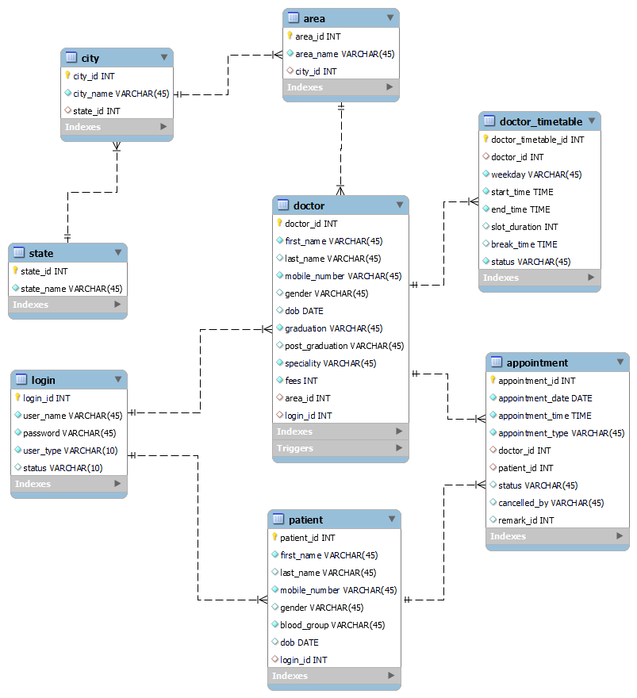

**E-R diagram shows database of Connect To Your Doctor**

**8. Snapshots:**

**8.1 Home Page:**

Following snapshot shows the Home page for Connect To Your Doctor.

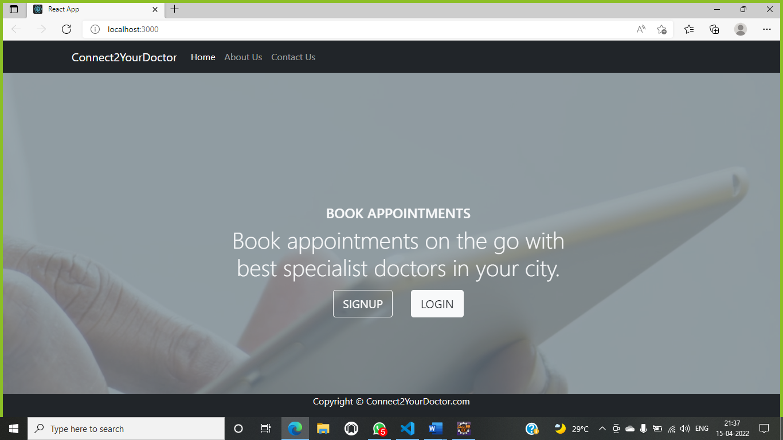

This page contains following controls

* Home
* About Us
* Contact Us
* Sign Up (Patient)
* Login (Admin, Doctor, Patient)

**8.2 About and Contact Page**

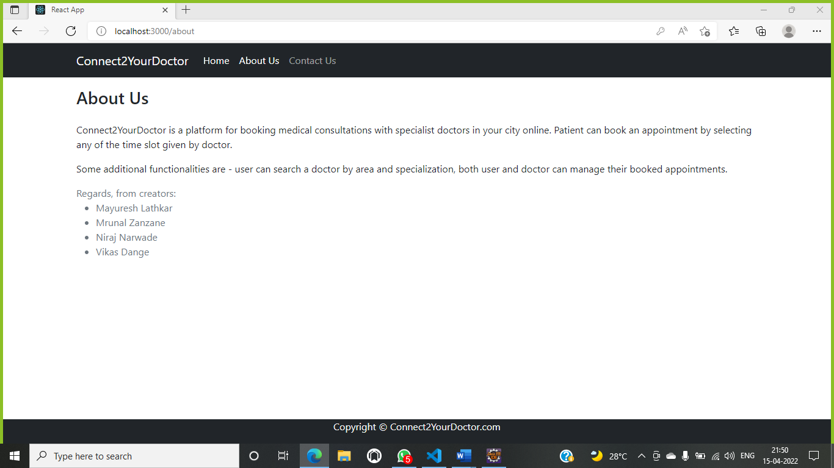

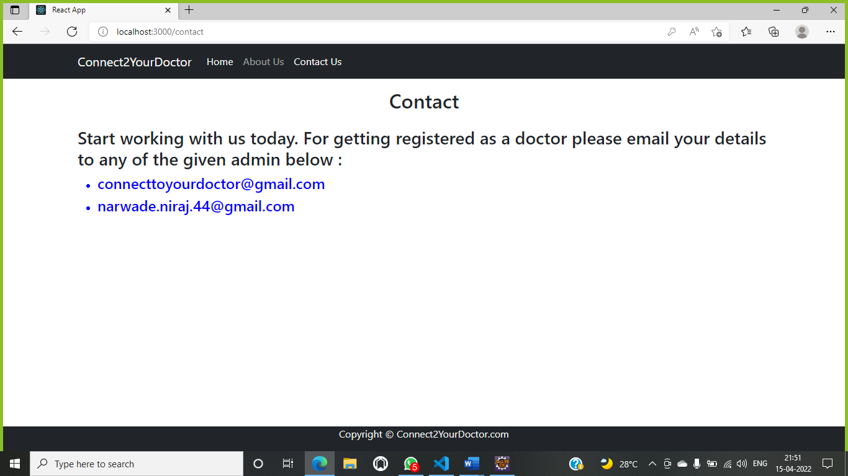

**8.3 Login Page**

Following snapshot shows the Login page for Connect To Your Doctor.

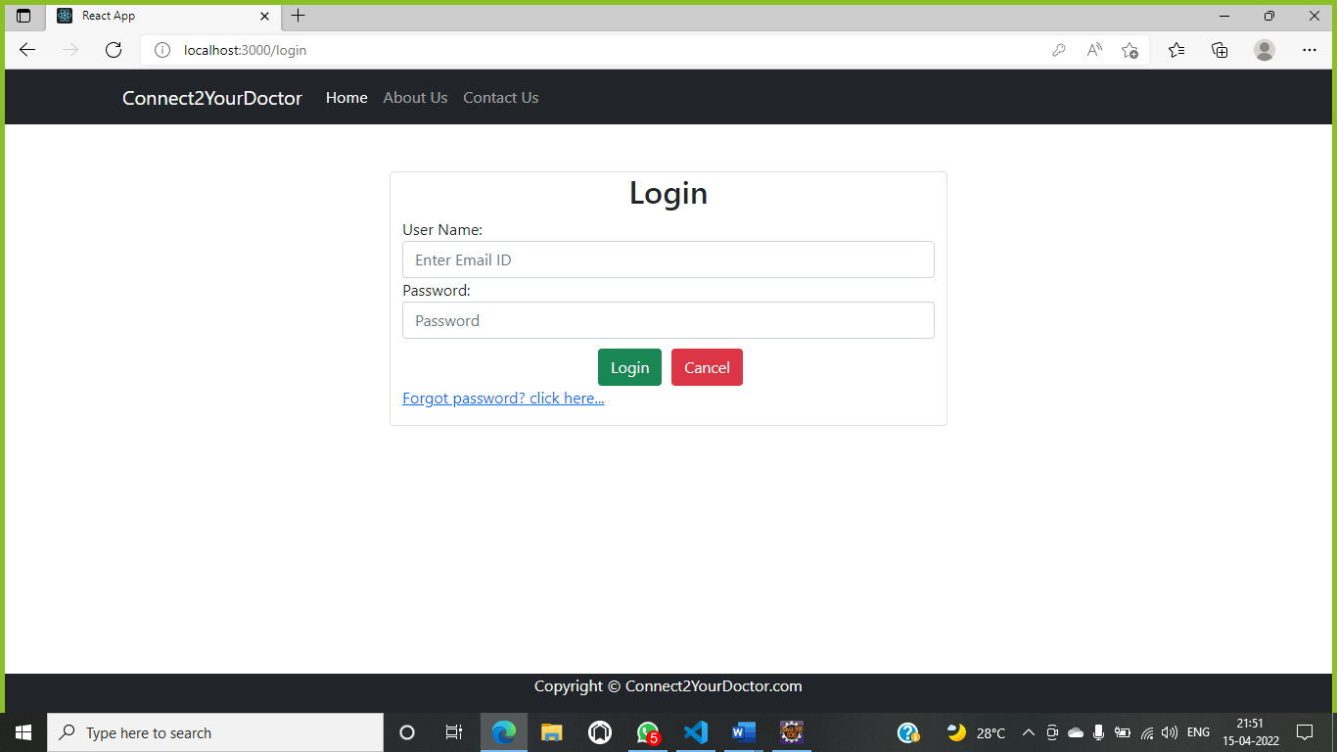

**8.4 Patient Registration Page**

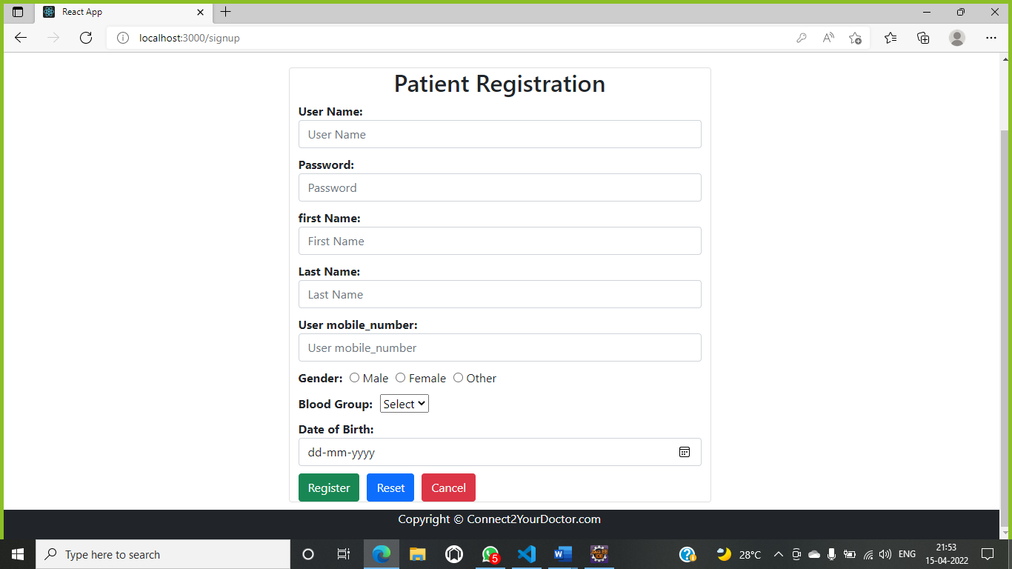

**8.5 Admin Dashboard**

**8.5.1 Admin Home Page**

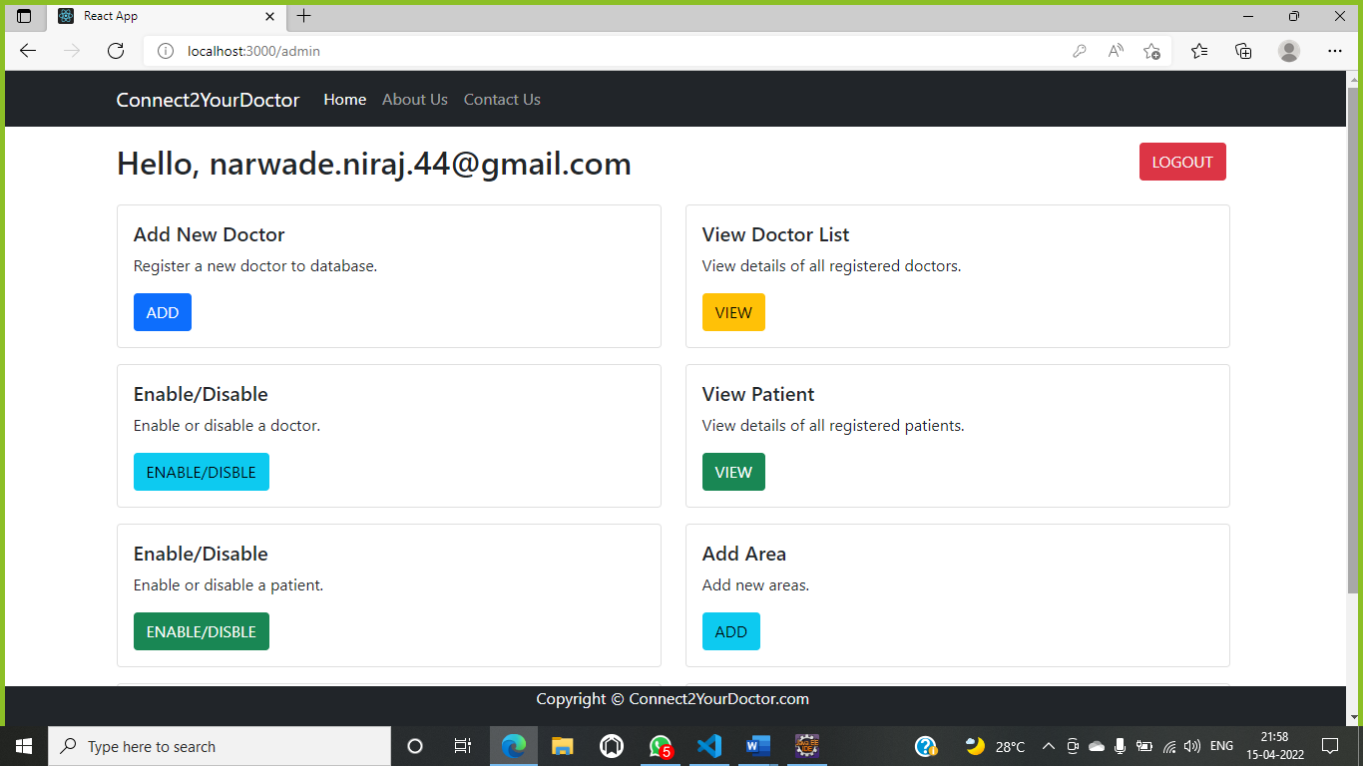

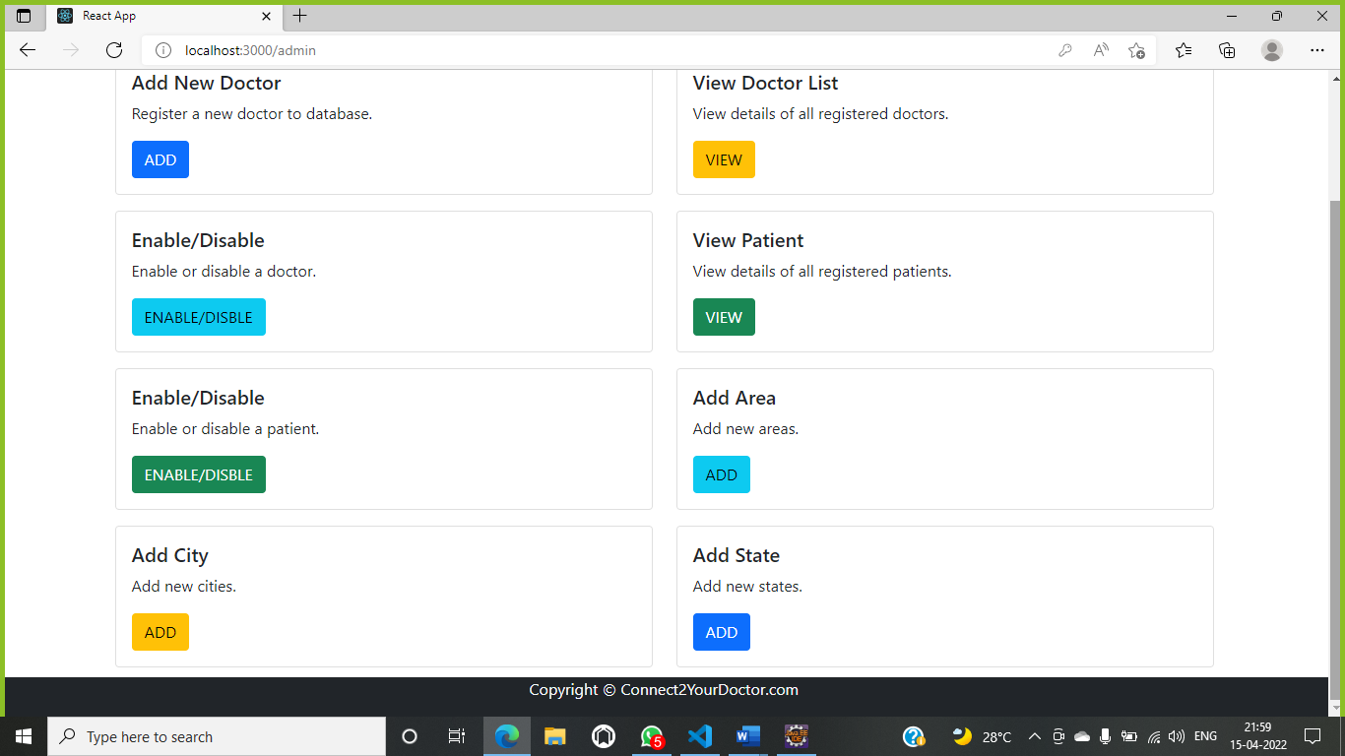

**8.5.2 Doctor Registration Page**

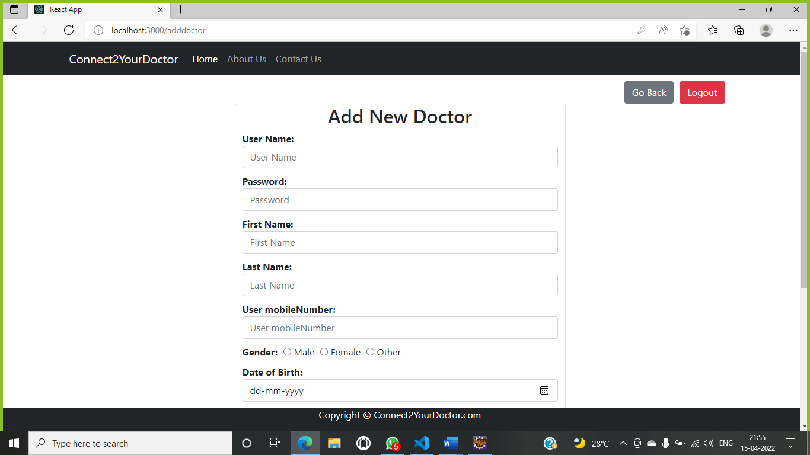

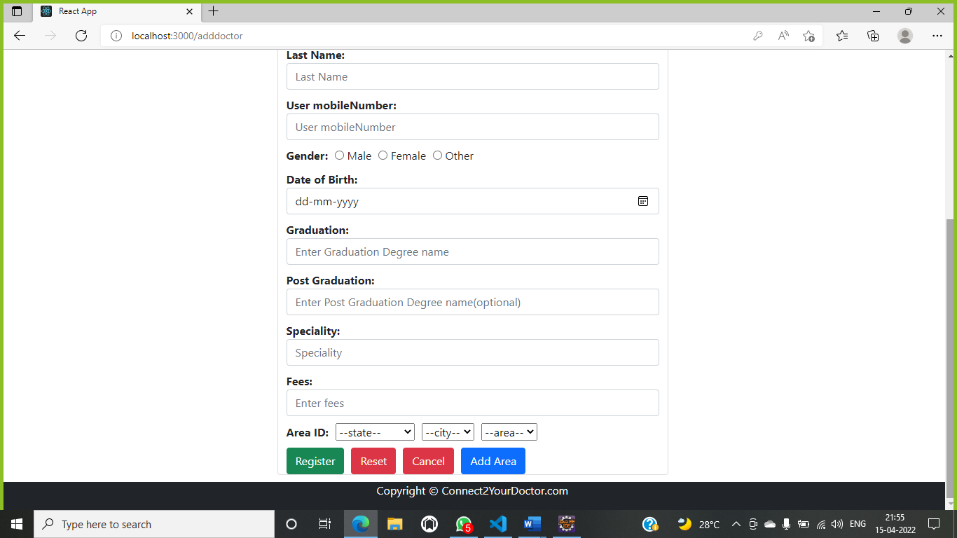

**8.5.3 View Doctor**

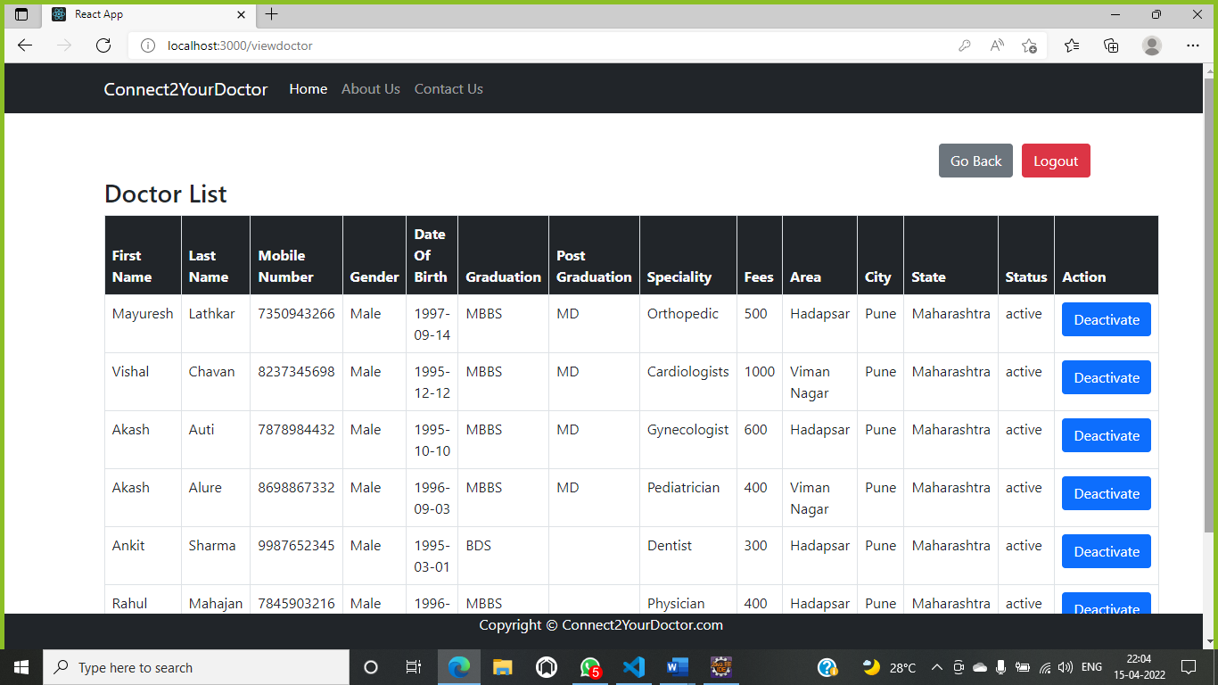

**8.5.4 View Patient**

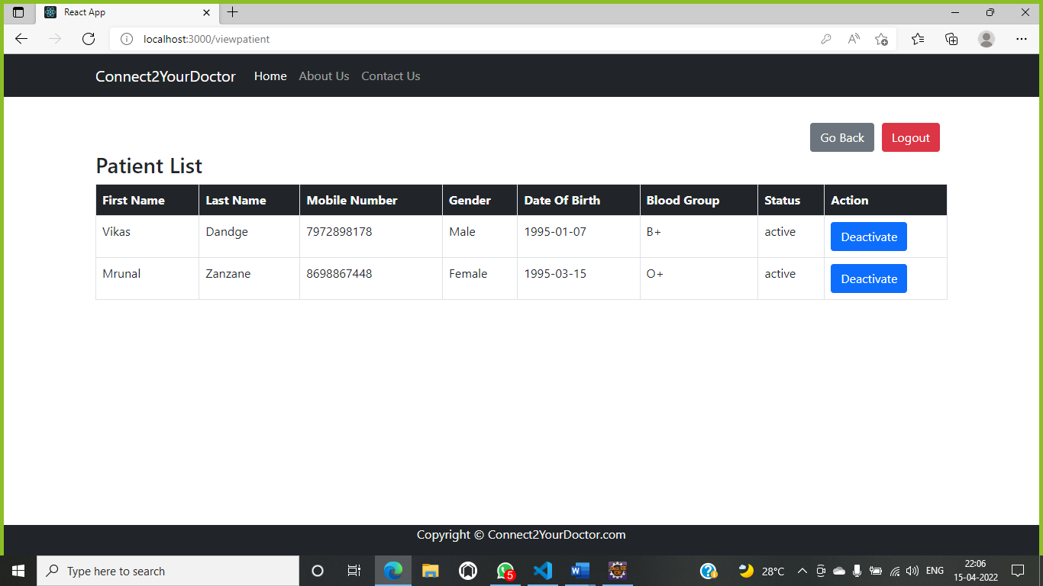

**8.5.5 Manage Account**





**8.5.6 Manage Location**

8.5.6.1 Add Area

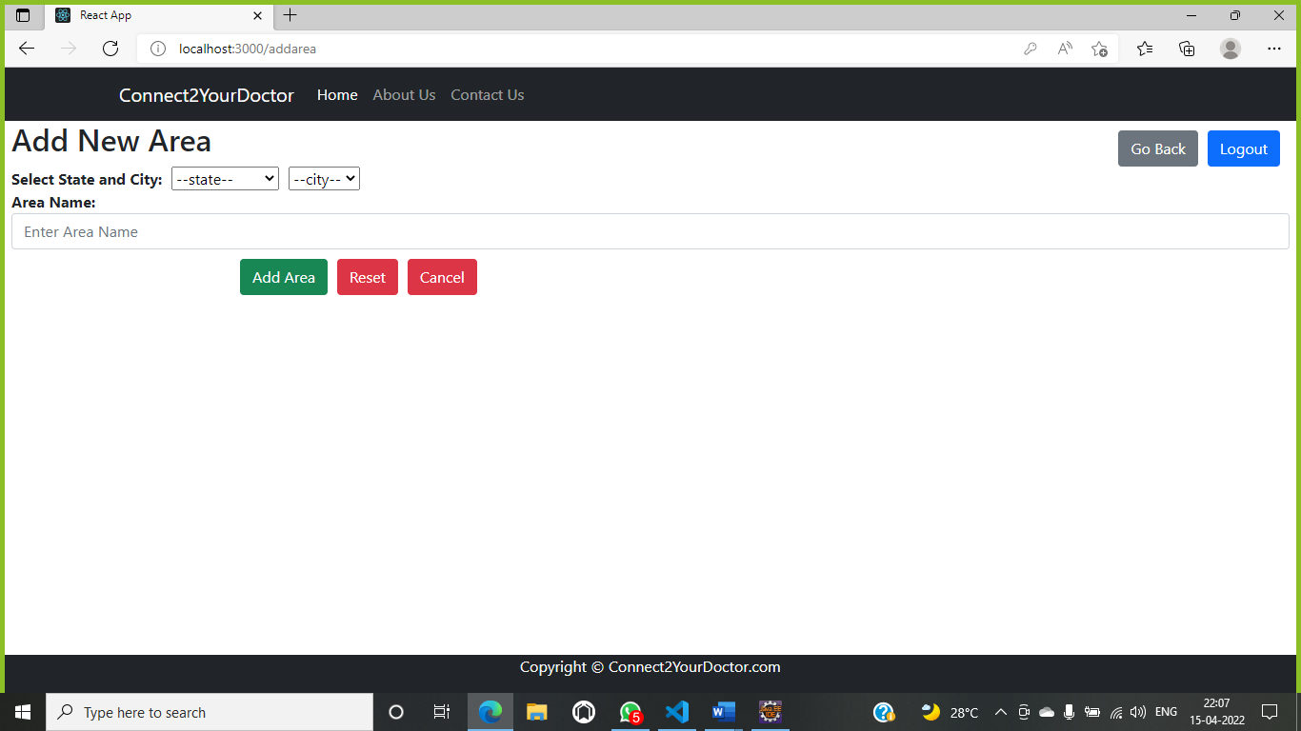

8.5.6.2 Add City

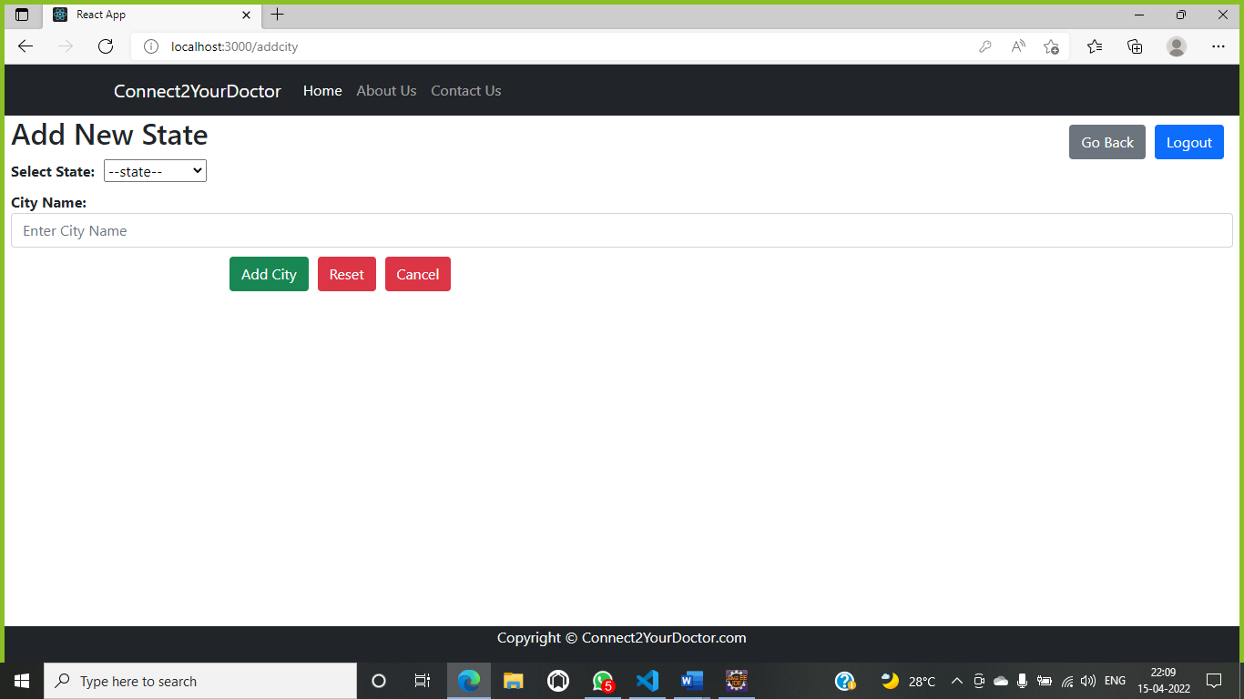

8.5.6.3 Add State

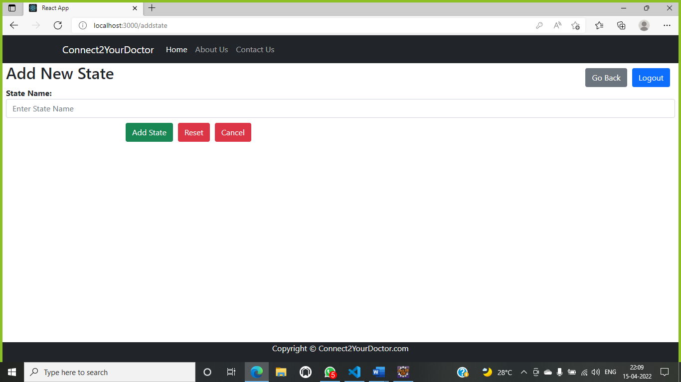

**8.6 Doctor Dashboard**

**8.6.1 Doctor Home Page**

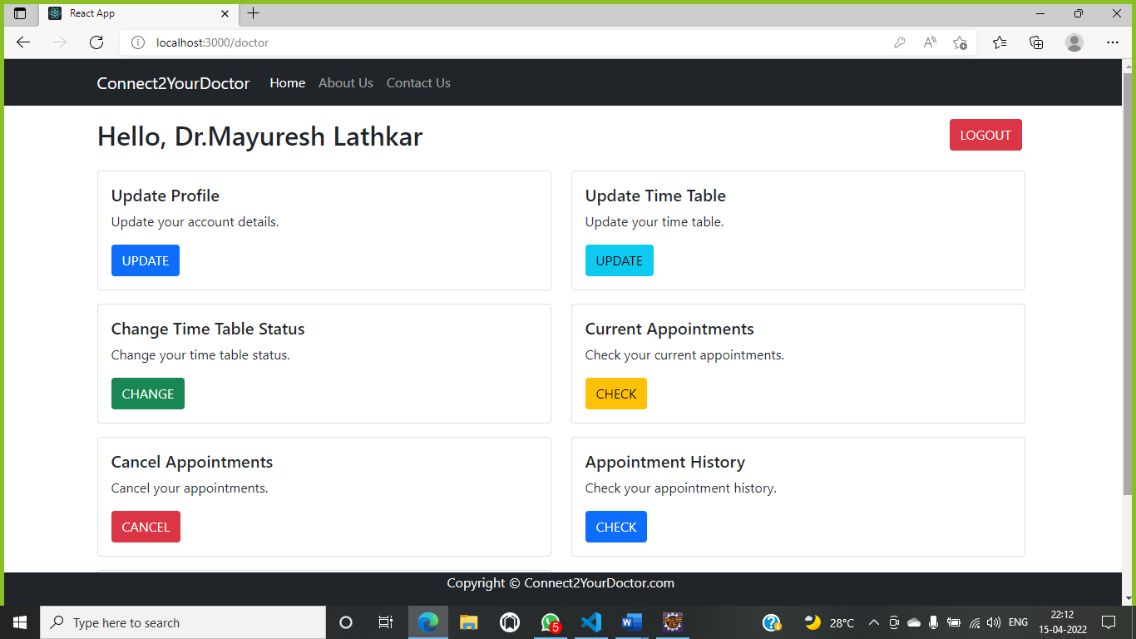

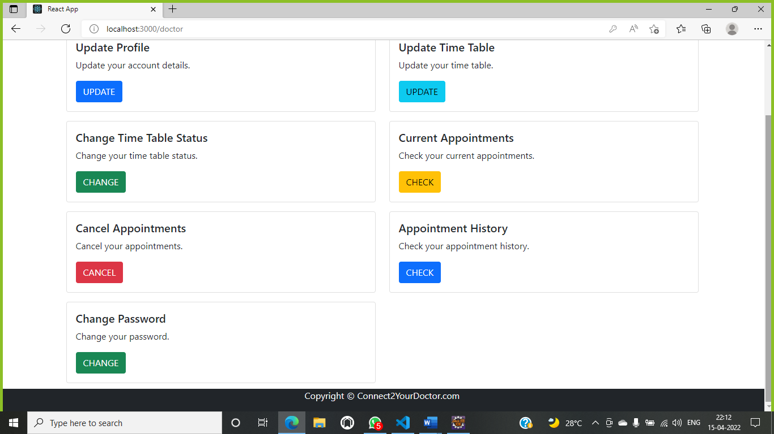

**8.6.2 Update Profile**

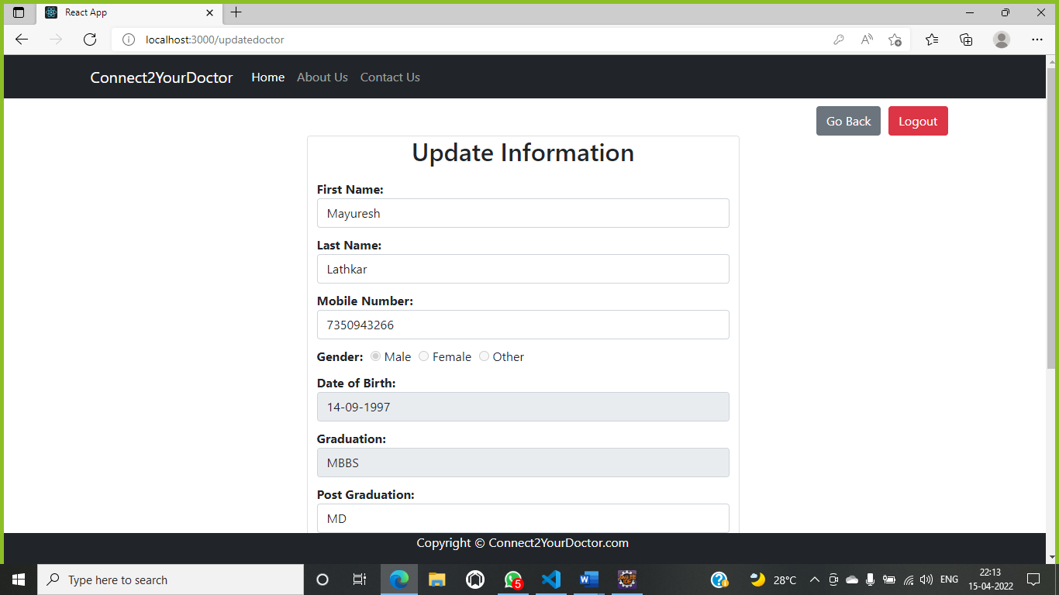

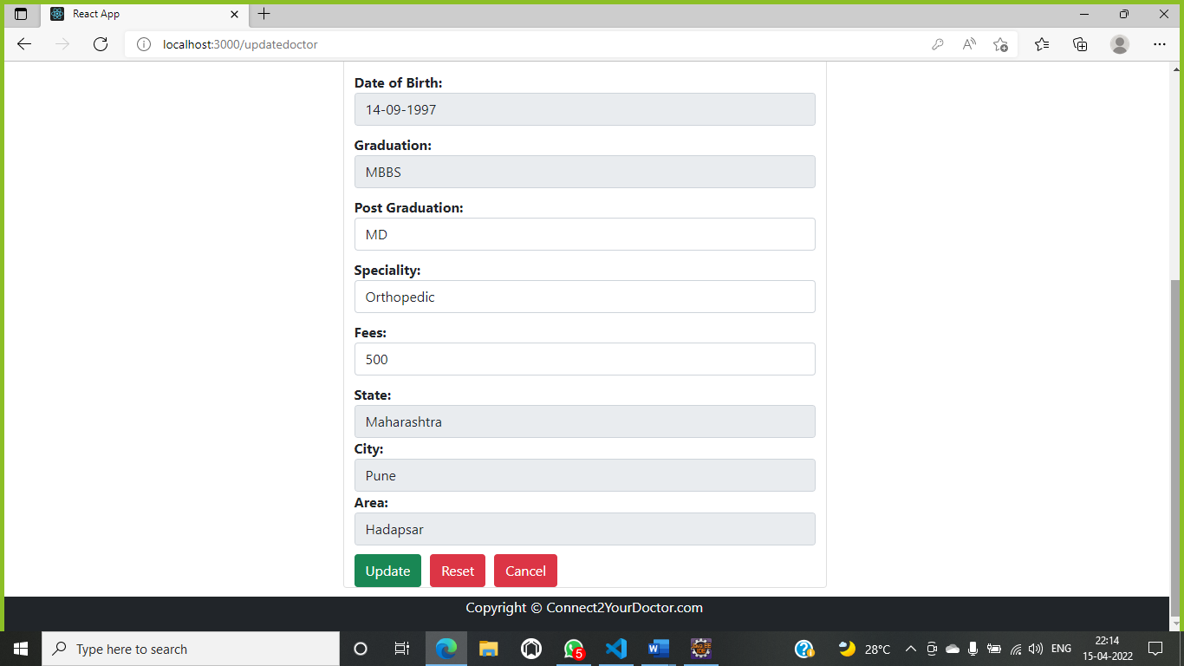

**8.6.3 Manage Time Table**

8.6.3.1 Update Status

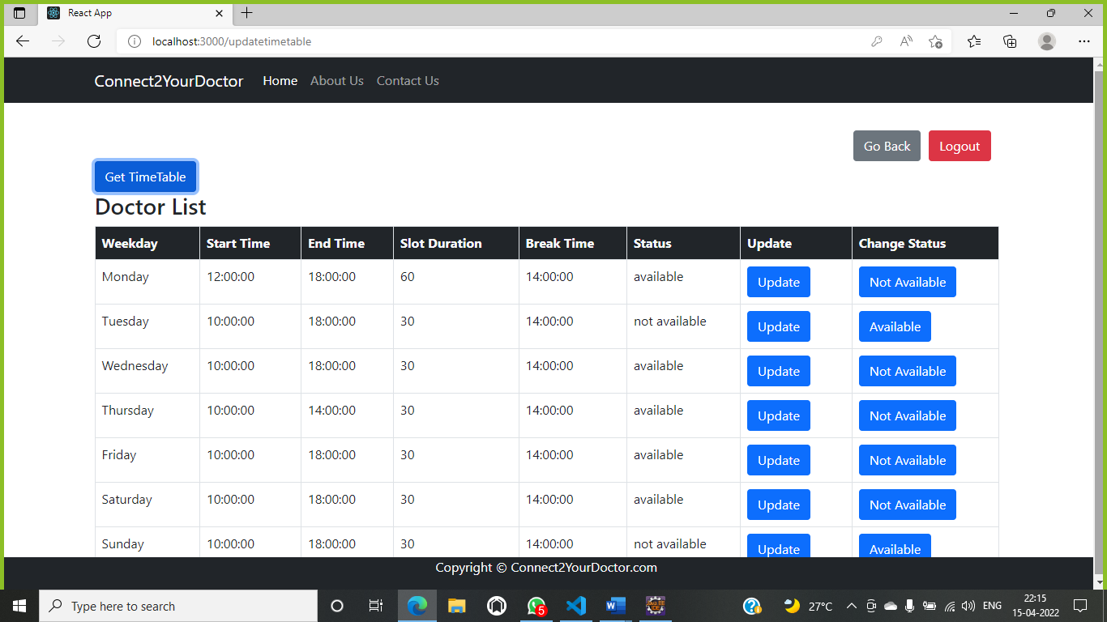

8.6.3.2 Change Time Table

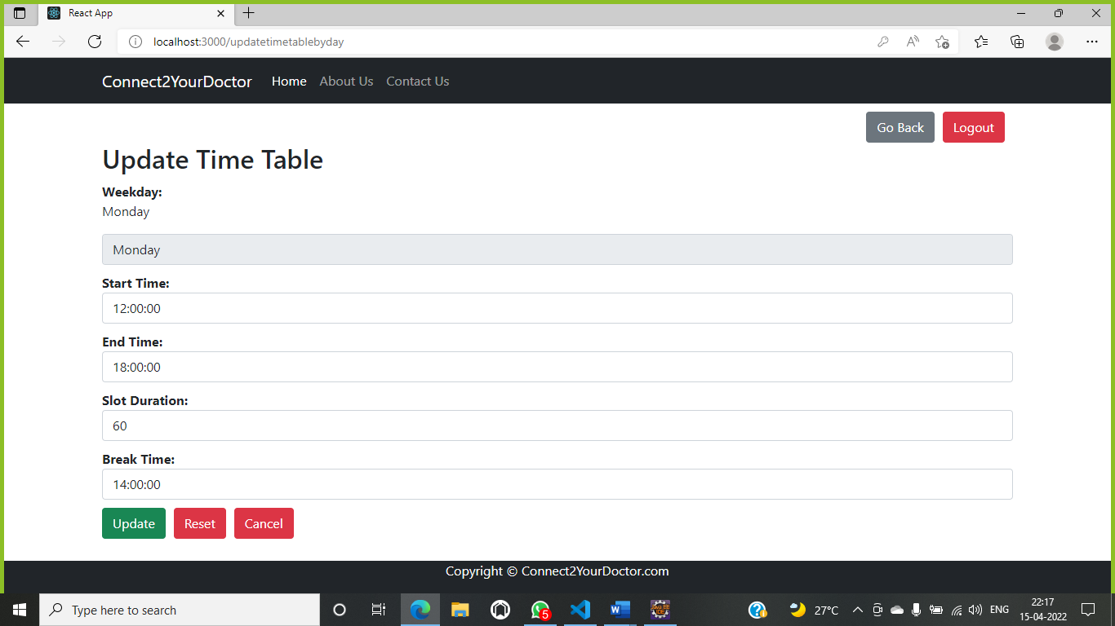

**8.6.4 View/Cancel Appointment**

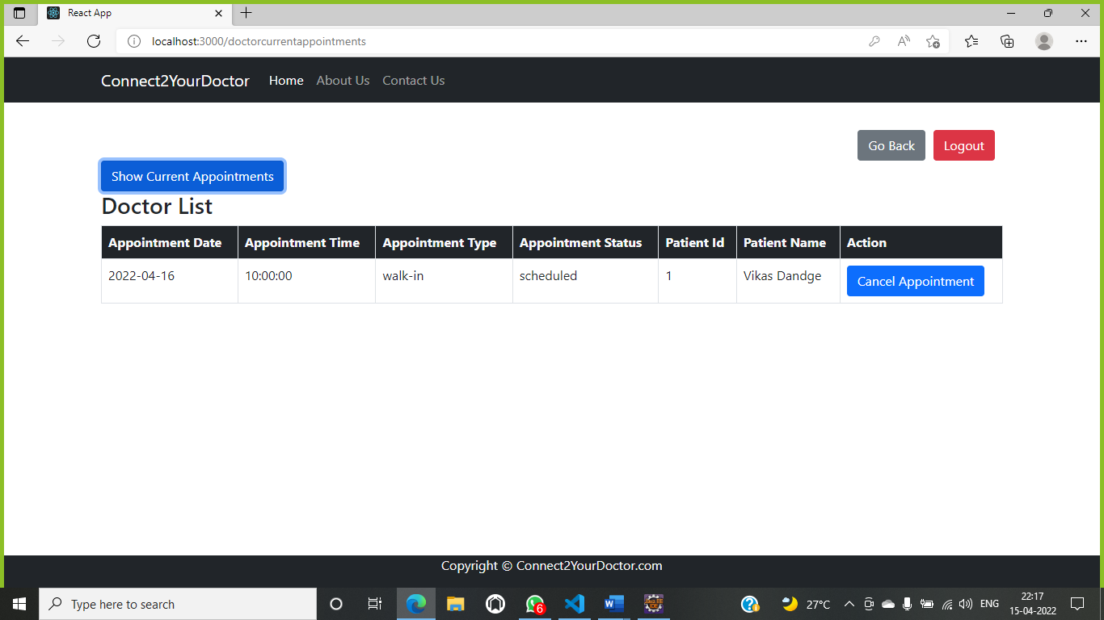

**8.6.5 Appointment History**

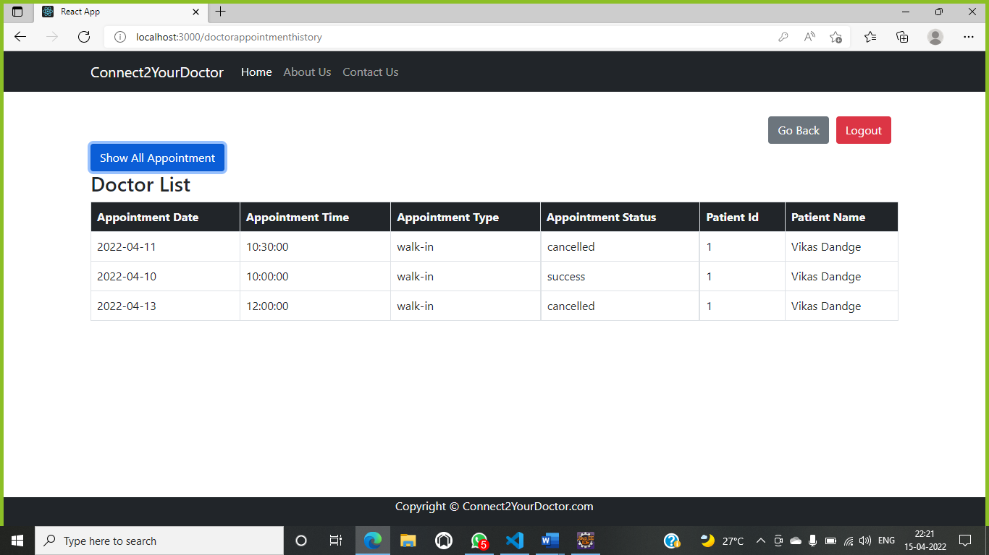

**8.6.6 Change Password**

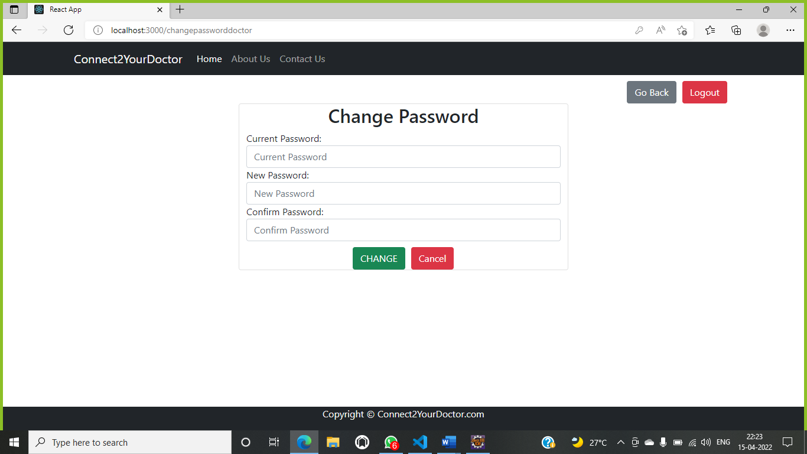

**8.7 Patient Dashboard**

**8.7.1 Home Page**

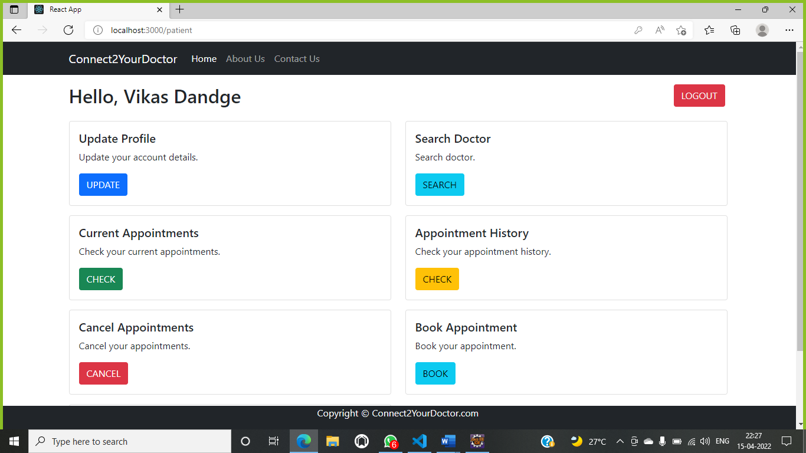

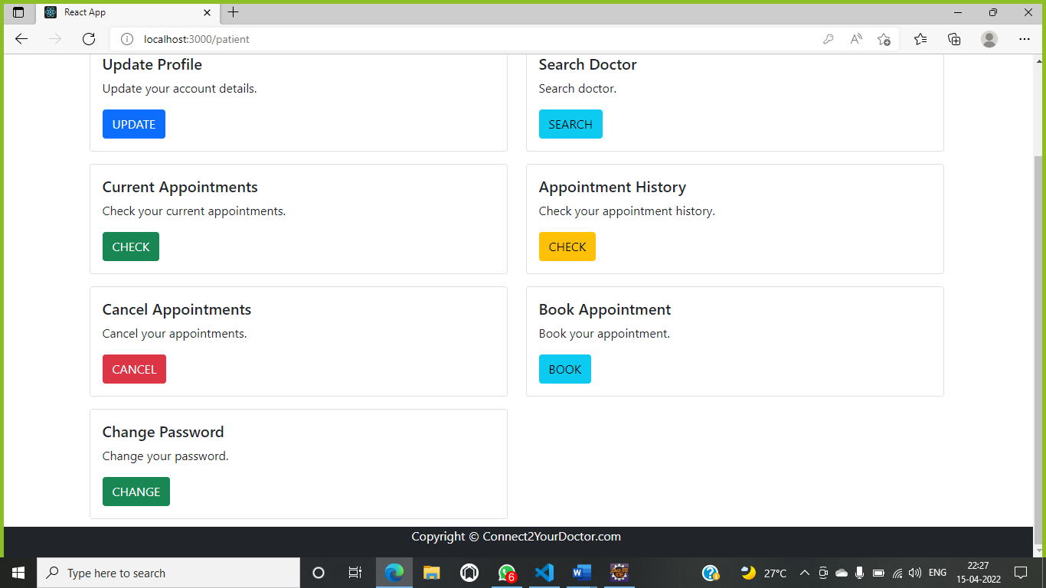

**8.7.2 Update Profile**

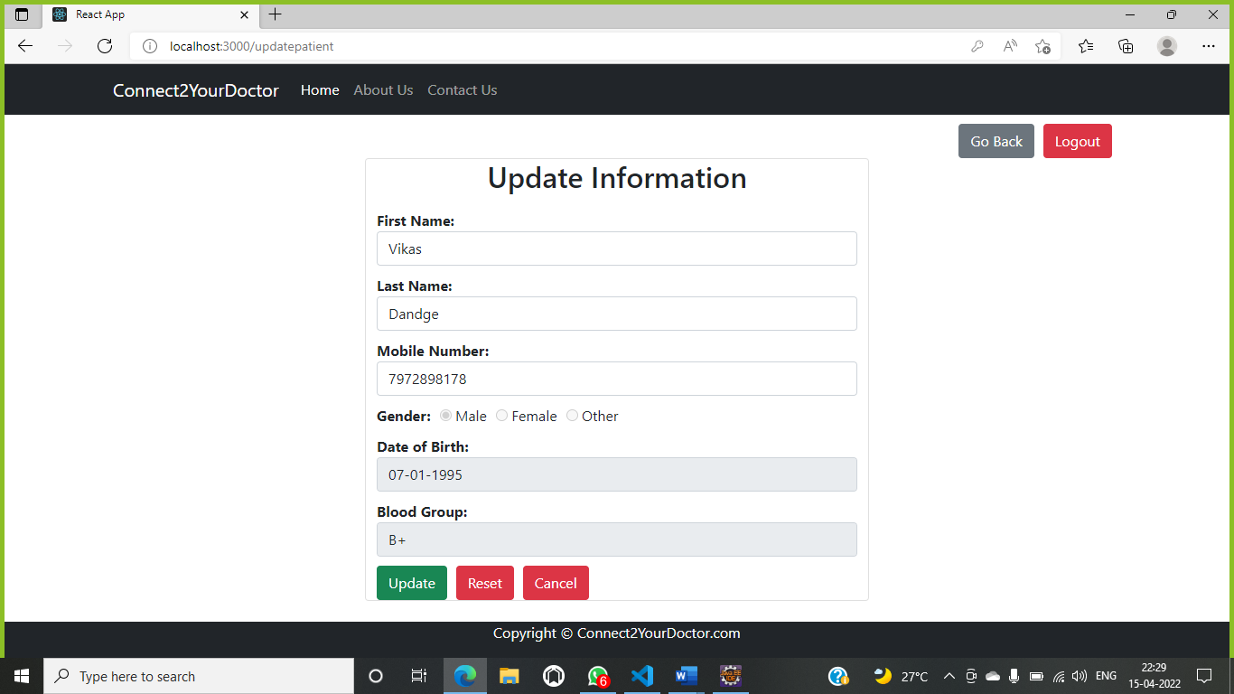

**8.7.3 Search Doctor**

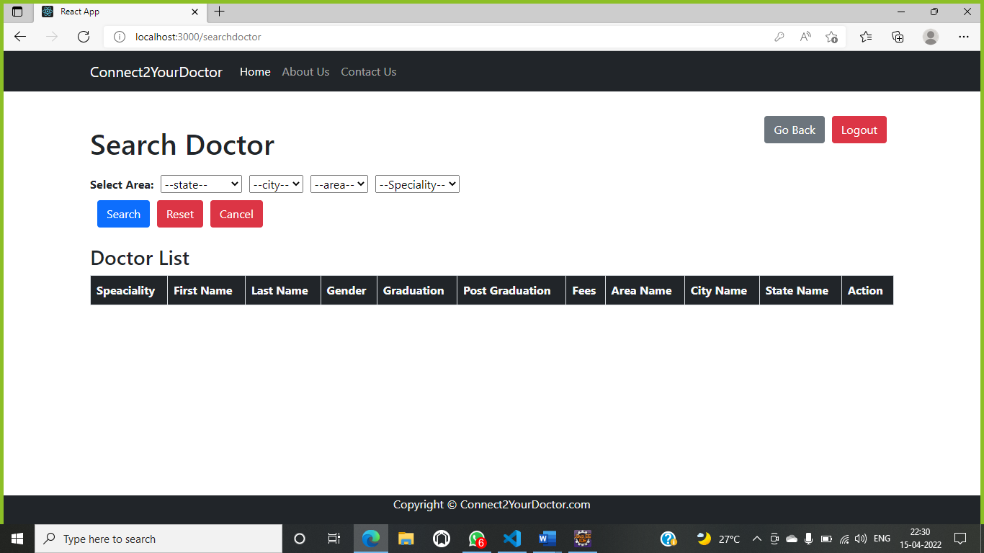

**8.7.4 Book Appointment**

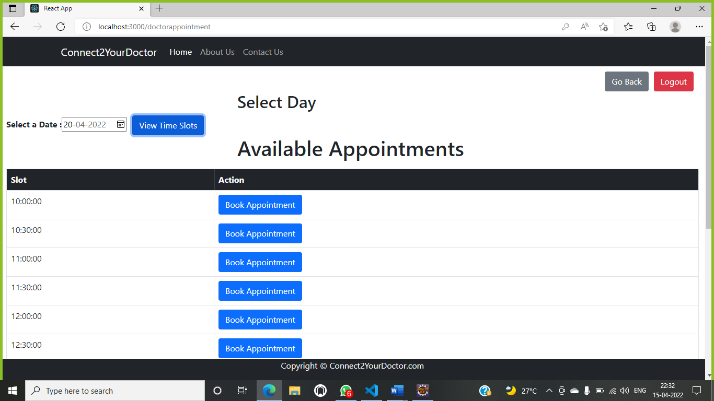

**8.7.5 View/Cancel Appointment**

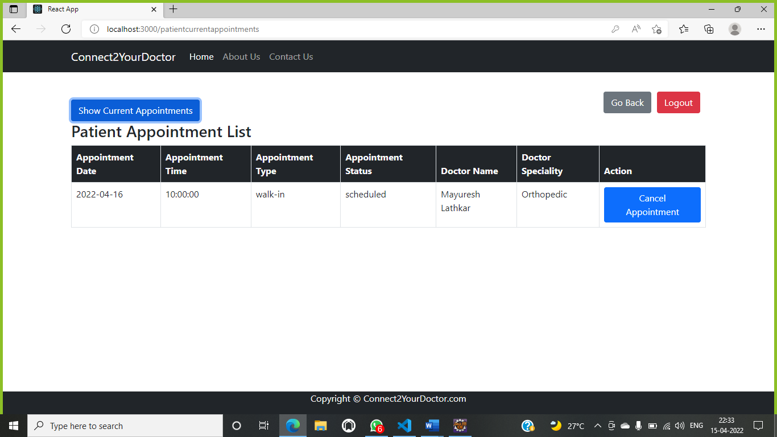

**8.7.6 Appointment History**

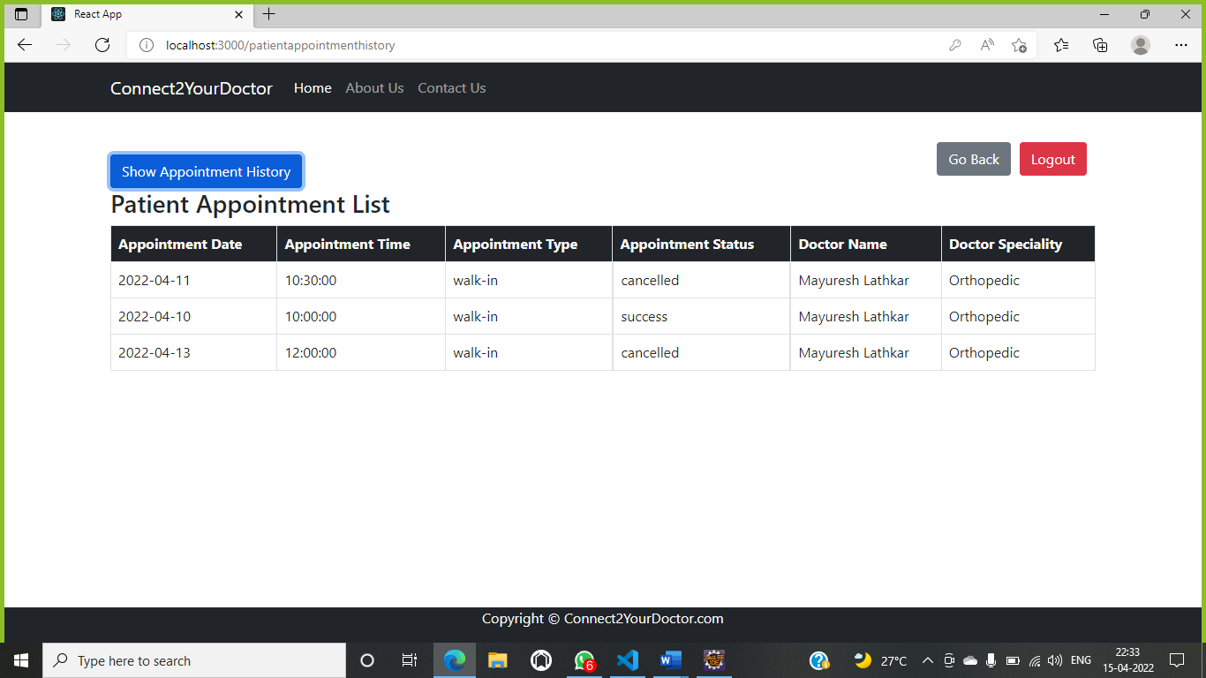

**8.7.7 Change Password**

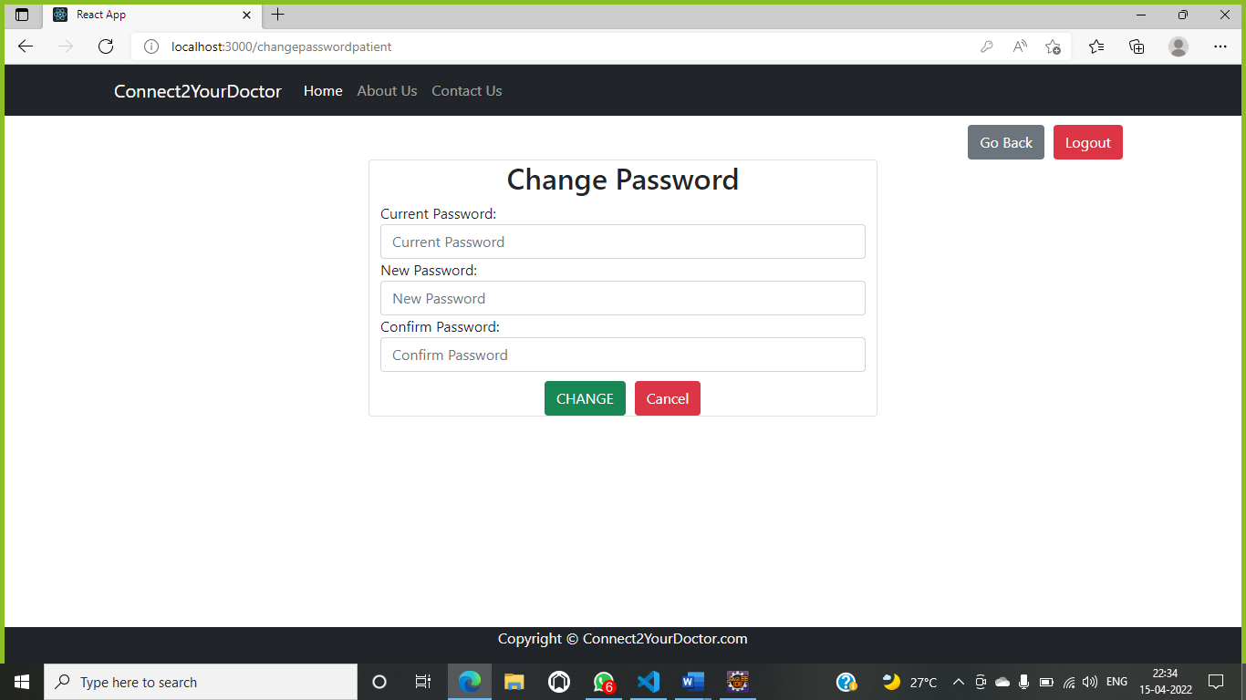

**9. CONCLUSION AND FUTURE SCOPE**

**9.1 Future Scope**

• We can add Online Consultation and online fee payment

• Home visit of doctor

• Blood Bank

• Pathology (Home Service)

**9.1 Conclusion**

Internet is changing the world. Though it is not possible to entirely switch the healthcare sector to online mode. But definitely it can help in bridging the gap between Patient and Doctor. Our project Connect To Your Doctor serves the purpose of bridging the gap. It makes easy for the patient to search for the doctor in his/her locality or in any other locality. Addition to this patient can also search for the doctor based on the doctor’s specialty.